UP TO 6 YEARS OF AGE – Competition closes Wednesday 12th April – Judging Tuesday 18th April 2017
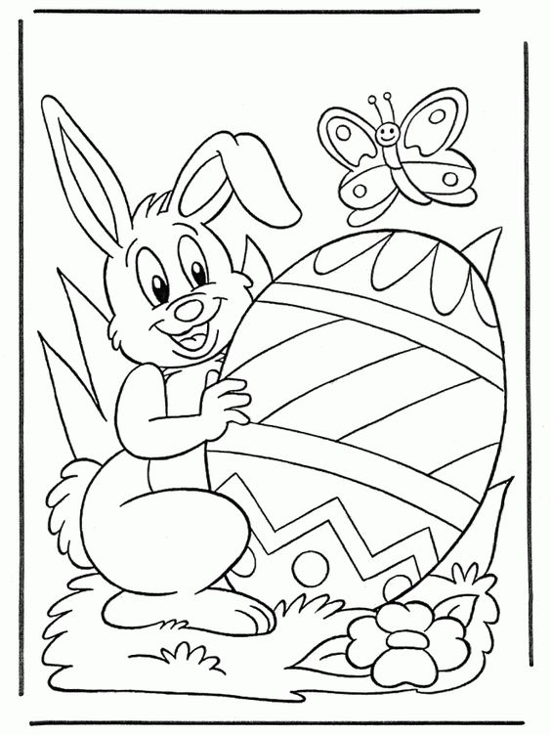

NAME:…………………………………………………………………………………….. AGE:……………………………

ADDRESS:……………………………………………………………………………………………………………………………………………………………….

………………………………………………………………………………………………. PHONE NUMBER:………………………………………………

PRIZES KINDLY DONATED BY:
Churton Park New World, Wellington City Council Libraries & Johnsonville Keith Spry Pool
ADULT PAPER CRAFT & COLOURING GROUP – Welcomes New Members
Each Tuesday 11.00am to 12.30pm – Churton Park Community Centre
AGES 7 to 10 – Competition closes Wednesday 12th April – Judging Tuesday 18th April 2017

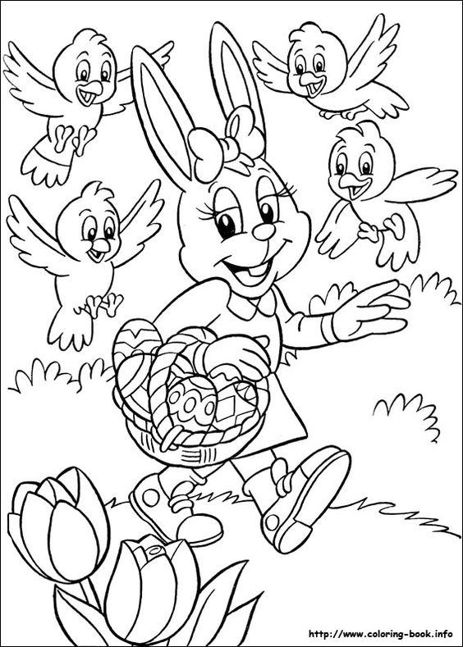

NAME:…………………………………………………………………………………….. AGE:……………………………

ADDRESS:……………………………………………………………………………………………………………………………………………………………….

………………………………………………………………………………………………. PHONE NUMBER:………………………………………………

PRIZES KINDLY DONATED BY:
Churton Park New World, Wellington City Council Libraries & Johnsonville Keith Spry Pool
ADULT PAPER CRAFT & COLOURING GROUP – Welcomes New Members
Each Tuesday 11.00am to 12.30pm – Churton Park Community Centre

AGES 11 TO 14 – Competition closes Wednesday 12th April – Judging Tuesday 18th April 2017
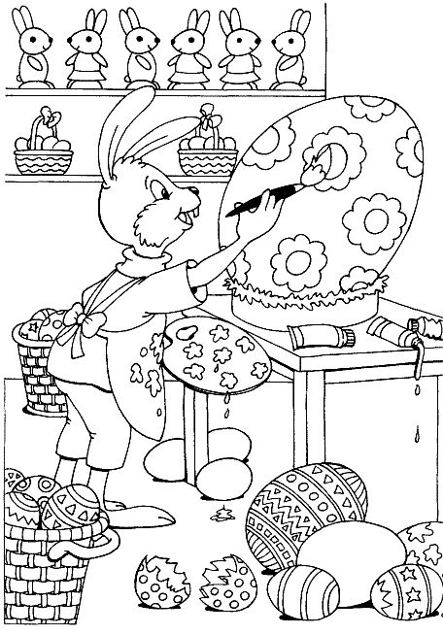

NAME:…………………………………………………………………………………….. AGE:……………………………

ADDRESS:……………………………………………………………………………………………………………………………………………………………….

………………………………………………………………………………………………. PHONE NUMBER:………………………………………………

PRIZES KINDLY DONATED BY:
Churton Park New World, Wellington City Council Libraries & Johnsonville Keith Spry Pool
ADULT PAPER CRAFT & COLOURING GROUP – Welcomes New Members
Each Tuesday 11.00am to 12.30pm – Churton Park Community Centre
AGES 15 TO 150 – Competition closes Wednesday 12th April – Judging Tuesday 18th April 2017
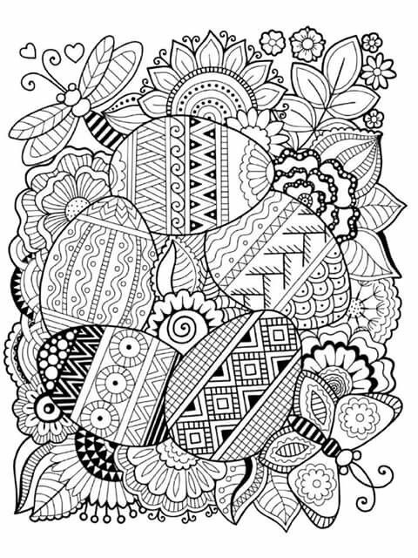

NAME:…………………………………………………………………………………….. AGE:……………………………

ADDRESS:……………………………………………………………………………………………………………………………………………………………….

………………………………………………………………………………………………. PHONE NUMBER:………………………………………………

PRIZES KINDLY DONATED BY:
Churton Park New World, Wellington City Council Libraries & Johnsonville Keith Spry Pool
ADULT PAPER CRAFT & COLOURING GROUP – Welcomes New Members
Each Tuesday 11.00am to 12.30pm – Churton Park Community Centre

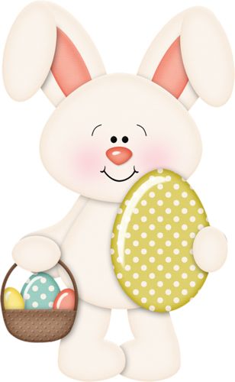 | EASTER COLOURING IN COMPETITION  EASTER IS JUST AROUND THE CORNER…… The eggs are being rounded up by the rabbits, ready for distribution to the children.  The Churton Park Community Centre Adult Paper Craft and Colouring Group, wish to celebrate, with an EASTER COLOURING IN COMPETITION, for all ages.  We would love to see bold use of colour and additional creativity e.g. the addition of texture or recycled items e.g. wool, tin foil, glitter or similar, to make your art work stand out from the rest.  There are four age categories so everyone in the family can participate. The age Groups are:  - Up to 6 years old  - Ages 7 to 10 years old  - Ages 11 to 14 years old  - Ages 15 to 150 years old  Entry pictures can be collected from and returned to:  - Churton Park Community Centre, 10am - 2pm Mon- Fri.  - Johnsonville Library, 5 Broderick Road, Johnsonville Mon – Thur 10am – 5.30pm, Fri 10am – 8pm & Sat 10am – 4pm  - Tawa Library, 158 Main Rd, M, T, W & F 10am – 5.30pm, Thur 10am – 8pm and Sat 10am – 4pm  - Churton Park School – for students & parents (School Office)  - Amesbury School – for students & parents (see Helen in the Office)  - Churton Park Kindergarten – for children & parents  The competition closes Wednesday 12th April 2017. Judging will be Tuesday 18th April 2017.  PRIZES DONATED BY: Churton Park New World, Wellington City Council Libraries & Johnsonville Keith Spry Pool
PLEASE HAVE FUN

The Churton Park Community Centre Adult Paper Craft and Colouring Group meet each Tuesday between 11am and 12.30pm at Churton Park Community Centre, 75 Lakewood Avenue. Cost is $2.00 per person. We welcome new members.

Please call in, or phone the centre on 830 4802 or email cpcc@wcc.govt.nz if you would more information.

